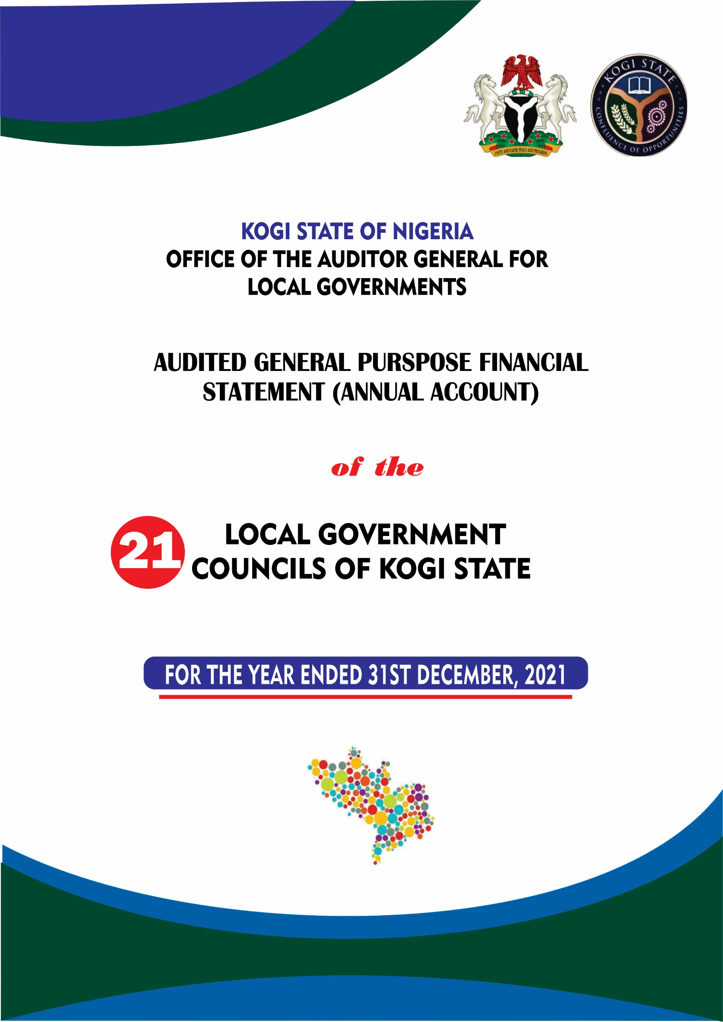

AUDITED GENERAL PURPOSE FINANCIAL STATEMENTS
(ACCRUAL BASED)

OF THE

21 LOCAL GOVERNMENT COUNCILS OF KOGI STATE
FOR THE YEAR ENDED 31ST DECEMBER, 2021

PRESENTED TO

KOGI STATE HOUSE OF ASSEMBLY

BY

AUDITOR-GENERAL FOR LOCAL GOVERNMENT
Alh. Usman Ododo B.Sc., ACA, CPFA, MNIN

JUNE, 2022
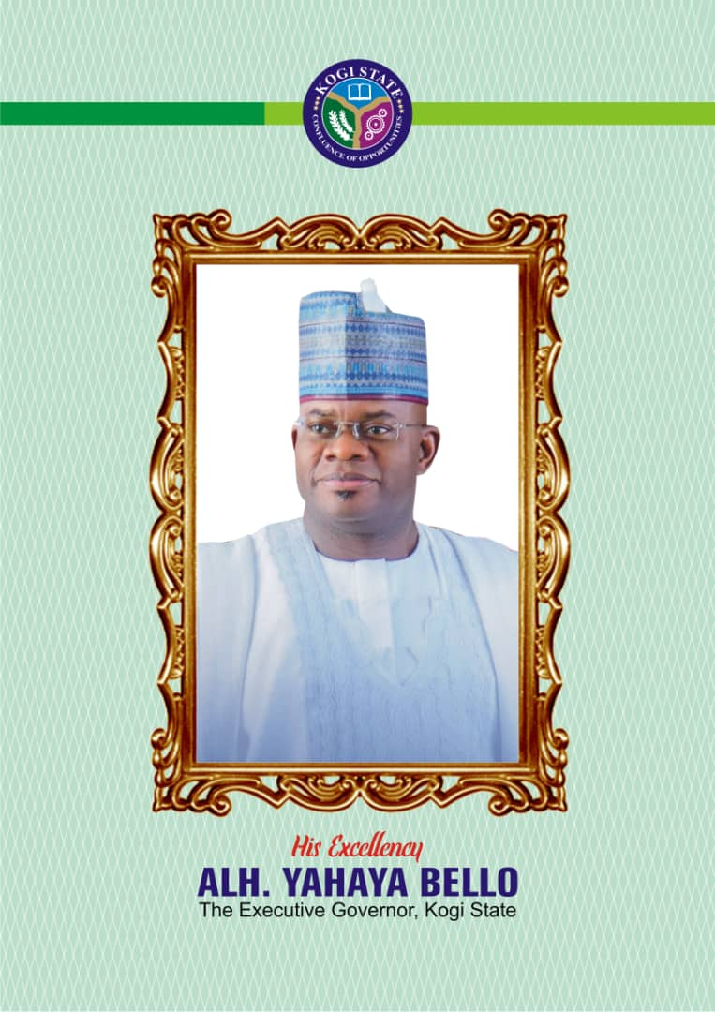
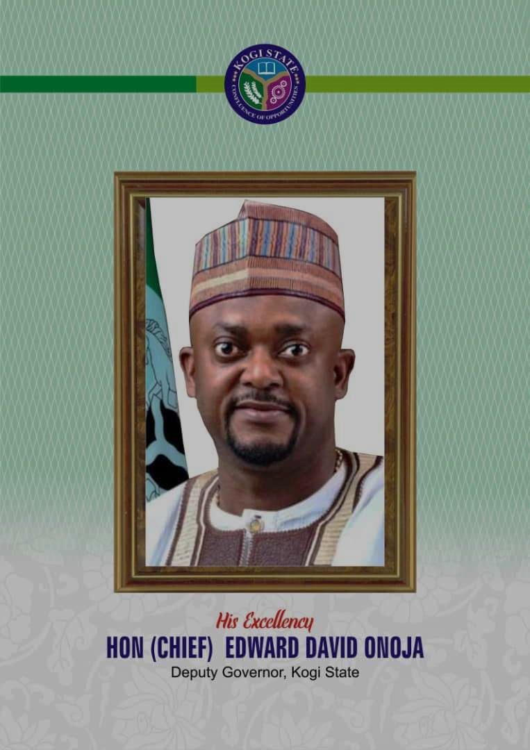
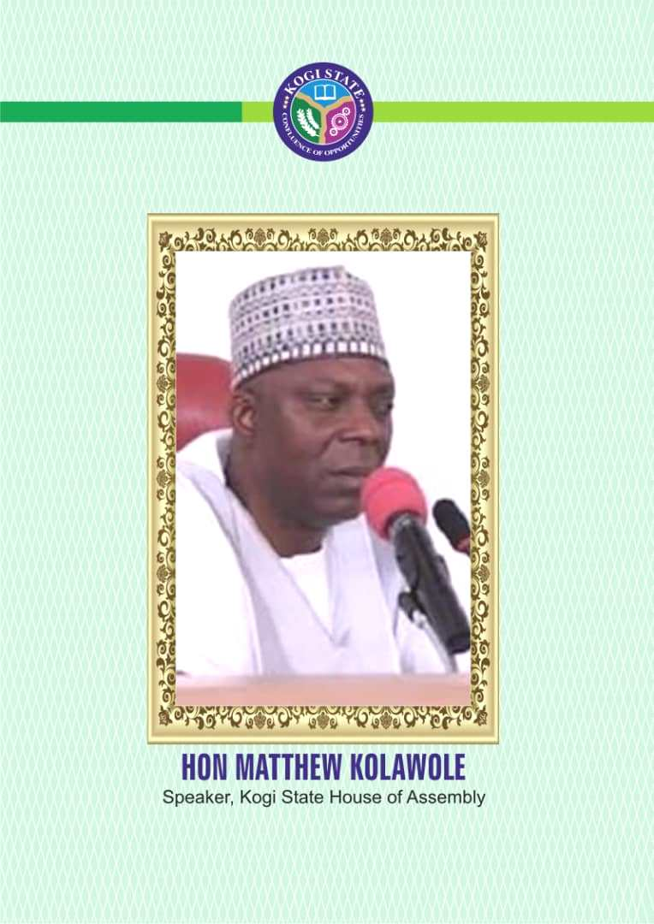

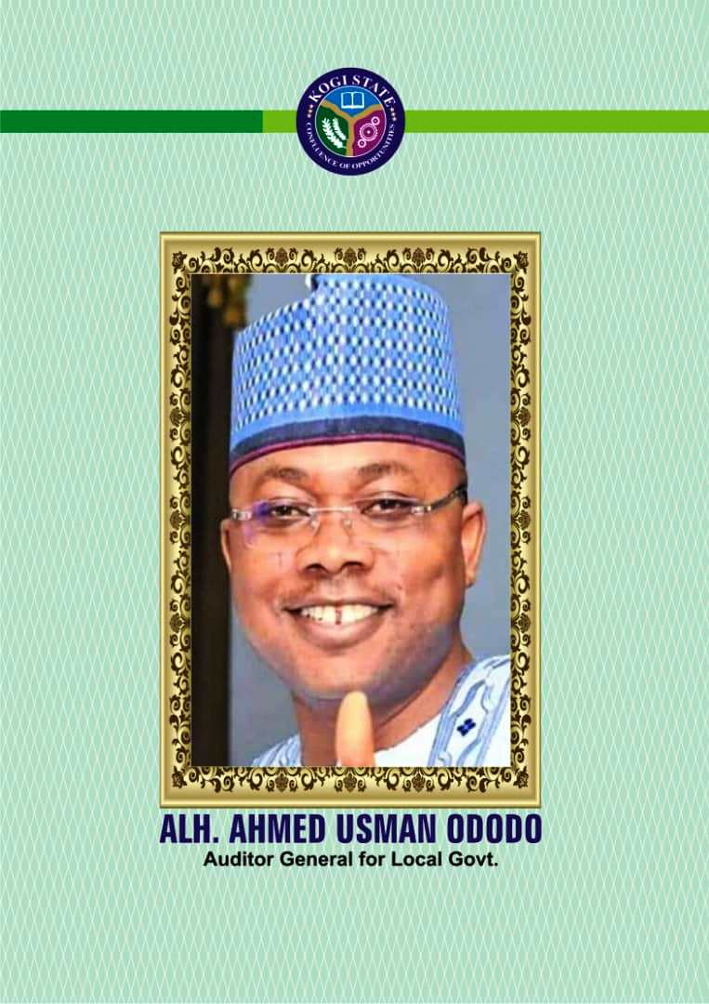

TABLE OF
CONTENT

Pages

Table of Contents i
Report of the Auditor-General for Local Government ii
Financial Statement of Adavi Local Government Council 1 - 18
Financial Statement of Ajaokuta Local Government Council 19 - 36
Financial Statement of Ankpa Local Government Council 37 - 58
Financial Statement of Bassa Local Government Council 59 - 74
Financial Statement of Dekina Local Government Council 75 - 94
Financial Statement of Ibaji Local Government Council 95 - 114
Financial Statement of Idah Local Government Council 115 - 134
Financial Statement of Igalamela/Odolu Local Government Council 135 - 154
Financial Statement of Ijumu Local Government Council 155 - 174
Financial Statement of Kabba Bunu Local Government Council 175 - 196
Financial Statement of Kogi Local Government Council 197 - 214
Financial Statement of Lokoja Local Government Council 215 - 234
Financial Statement of Mopa-Muro Local Government Council 235 - 254
Financial Statement of Ofu Local Government Council 255 - 274
Financial Statement of Ogori-Magongo Local Government Council 275 - 296
Financial Statement of Okehi Local Government Council 297 - 314
Financial Statement of Okene Local Government Council 315 - 334
Financial Statement of Olamaboro Local Government Council 335 - 356
Financial Statement of Omala Local Government Council 357 - 374
Financial Statement of Yagba East Local Government Council 375 - 392
Financial Statement of Yagba West Local Government Council 393 – 410

Audit Certificate

Report of the Auditor general For Local Government, Kogi State on the financial statement of the 21 Local government Councils, Kogi State for the Year Ended 31 December 2021.

In accordance with relevant section of the Constitution of the Federal Republic of Nigeria, 1999 as amended and Local Government Audit Law 2021, I have audited the Accounts and Financial Statements of the 21 Local Government Councils, Kogi State, for the year ended 31st December, 2021, which has been prepared in accordance with the requirements of the International Public Sector Accounting Standards (IPSAS), Financial Reporting Council (FRC) and other relevant Laws, rules and regulations.
Auditor-General for Local Government Responsibility
The responsibility of the Auditor General is to express an opinion on the financial statement of the 21 Local Government Council based on the audit conducted in accordance with the auditing standards as specified in the Kogi State Local Government Audit Laws 2021, and in accordance with the requirements of the International Standards on Auditing.

Basis of Opinion
We carried out the audit in line with the requirements of the International Standards on Auditing (ISA) issued by the International Federation of Accountants (IFAC) through the International Auditing and Assurance Standards Board (IAASB), and also in consonance with the advisories issued by International Organization of Supreme Audit Institutions (INTOSAI). Accordingly, the audits were planned and performed and all information and explanation considered necessary to provide reasonable assurance were obtained to ensure that the financial statements are free from material misstatements.

Opinion
In my opinion, the financial statements of the 21 Local Governments Councils of Kogi State for the year ended 31st December, 2021 show a true and fair view of the state of affairs, the cash flow and the financial position as at that date.
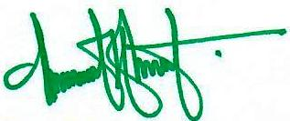

___________________________________
Alh. Usman Ododo B.Sc., ACA, CPFA, MNIN
The Auditor-General
for Local Government,
Kogi State.

