

KOGI STATE GOVERNMENT

STATE ARREARS REPORTING VERIFICATION AND CLEARANCE REPORT (SARVCR)

 | BREAKDOWN OF KOGI STATE DOMESTIC EXPENDITURE ARREARS FROM 2014-2018 FINANCIAL YEARS
 |  | DOMESTIC EXPENDITURE ARREARS | 2018 Financial Year | 2017 Financial Year | 2016 Financial Year | 2015 Financial Year | 2014 Financial Year
 | COA-CODE |  | =N= | =N= | =N= | =N= | =N=
 | 41040105 | CONTRACTUAL OBLIGATIONS | 28,934,435,963.24 | 18,798,931,683.39 | 4,968,245,969.44 | 2,854,528,053.22 | 589,262,161.00
 | 41040101 | SALARY ARREARS | 16,340,838,225.51 | 10,813,271,705.88 | 14,926,274,292.55 | 12,776,385,122.45 | -
 | 41040102 | PENSION & GRATUITY ARREARS | 12,216,707,890.00 | 14,504,353,299.50 | 18,091,113,648.18 | 18,730,264,173.64 | 5,358,075,445.40
 |  | ANNUAL TOTAL | 57,491,982,078.75 | 44,116,556,688.77 | 37,985,633,910.17 | 34,361,177,349.31 | 5,947,337,606.40
 | NOTE: The arrears figures reported is in Naira (₦) and it is the total amount of each type of arrears as per Domestic Database
 |  | 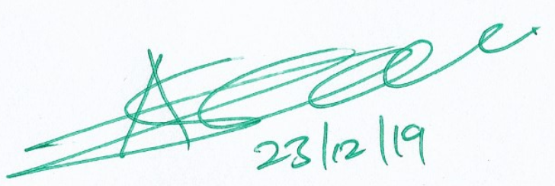 |  |  | 
 |  | Asiru Asiwaju Idris |  |  | Alhaji Momoh Jibrin
 |  | Hon. Comm. of Finance |  |  | Accountant-General

In an attempt to strengthen the recording, verification and reporting, Kogi State Government set up a Domestic Arrears Clearance Committee saddled with the responsibility of ensuring proper and adequate overall arrears clearance process, including recording, verification, classification, reporting, prioritization and clearance of government domestic expenditure arrears in the State and to oversee the work of the State towards achieving the key result of debt sustainability.
The duties of the committee include the following:
- Introduction of specific guidelines setting out the roles and responsibilities of individuals and institutions for the recording of domestic arrears. (i.e. the roles and responsibilities of each Primary Record Holder the entity primarily responsible for keeping the records for each type of arrears). This will include specific reporting requirements (i.e. the use of agreed recording templates and any supporting schedules) and timelines for submission to the committee (monthly).
- Introduction of specific guidelines setting out the roles and responsibilities of individuals and institutions for the verification of domestic arrears balances. i.e. the role of Internal Audit, Inspectorates, and contracted consultants. This will include reporting requirements (a validated copy of the agreed recording templates and any supporting schedules) and time-lines for submission to the Domestic Arrears Clearance Committee (monthly).
- The creation, maintenance and regular (monthly) update of an accurate internal domestic expenditure arrears database and the publicly-accessible online version of the database.

  - Oversight of the overall recording, verification and reporting processes for domestic expenditure arrears to ensure that they meet the requirements of SFTAS DLI #8 as described in the SFTAS verification protocols.
  - Ensure adequate classification of the arrears for prioritization purposes.
  - Develop the State’s Arrears Clearance Framework (ACF), including policies on prioritization and clearance of arrears.
  - Provide accurate monthly, quarterly, and annual reports that present the position for verified domestic arrears and the progress made in implementing the State’s ACF.
  - Provide data/documentation to support the verification of SFTAS DLI #8, including the State Arrears Recording, Verification and Clearance Report.

The Committee reports directly to the State Governor through the Honourable Commissioner for Finance and Economic Development, keeping the appointed SFTAS focal persons informed.
The Committee used its delegated authority to request for all necessary information which facilitates effective discharge of its functions.
In the process of performing its function, the Committee engaged the service of professional assistance for web design and management and incurred expenditures through the established procurement systems and in line with annual budget of the secretariat.
Within this reporting year, the state through the Domestic Arrears Clearance Committee requested that the primary record holders present contractors’ arrears records which were subjected to verification by the Monitoring and Evaluation dept of Ministry of Budget and Planning and Bureau of Public Procurement. As such, the arrears were verified appropriately. For the salaries and others staff claims, the arrears were also verified by the committee through the screening exercise conducted during the year.

Signed

Asiru Asiwaju Idris Momoh Jibrin

Hon. Commissioner of Finance State Accountant General

